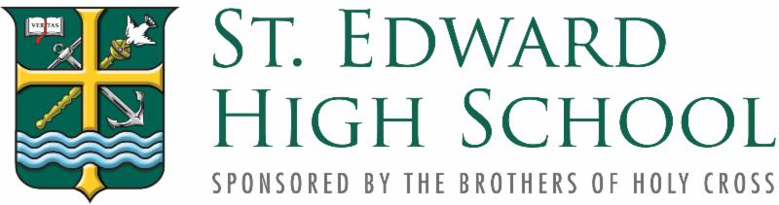
STOCK AND WIRING INSTRUCTIONS FOR GIFTS TO ST. EDWARD HIGH SCHOOL
Thank you for considering a gift of securities in support of St. Edward High School (TAX ID #34-0737808).
Gifts of securities often confer significant tax benefits on a donor. For example, contributions of appreciated securities held for over a year are generally deductible at market value, regardless of what the donor paid for them; moreover, the capital gains tax is avoided through such a gift.
To make a gift of securities, please notify the St. Edward High School representative listed below with complete donor information (name, address, phone number), the name and type of securities to be gifted (public, private, restricted, mutual fund, etc.), the number of shares, and the date you intend to make the gift.
TYPES OF TRANSFERS
1) DTC Transfer of Stock
To transfer securities to St. Edward High School via DTC, please use the following instructions:

Annual Fund Gifts
STATE STREET BANK & TRUST CO.
DTC PARTICIPANT #987
FFC: BJ60
FOR: ACCOUNT #650228
St. Edward High School Fund SD

Capital Campaign Gifts
STATE STREET BANK & TRUST CO.
DTC PARTICIPANT #987
FFC: BJ60
FOR: ACCOUNT # 654808
St. Edward High School
Capital Campaign Fund SD

Endowment Gifts
STATE STREET BANK & TRUST CO.
DTC PARTICIPANT #987
FFC: BJ60
FOR: ACCOUNT #650223
St. Edward High School
Endowment Fund SD
In order to promptly and accurately credit a security gift to the appropriate donor, it is essential that the transfer instructions include the donor’s name and address. Without this information, we are occasionally unable to identify the donors of certain securities.
If your broker requires further information, he or she should contact an Investment Office representative or:
Chris Seidl
Hirtle, Callaghan & Co.
Five Tower Bridge
300 Barr Harbor Drive, Suite 500
West Conshohocken, PA 19428
tel: (800) 242-9596 fax: (610) 828-7425
email: cseidl@hirtlecallaghan.com

2) Mutual Fund Transfer
Mutual fund units cannot be electronically transferred via DTC. The method used to transfer mutual funds to St. Edward High School varies, depending on how the fund units are held:

If your mutual fund is held in an account with the fund company, it may be possible to transfer it into an account in St. Edward High School’s name with the fund company. Please contact Peter Srsen in the finance office to determine if a St. Edward High School account exists:
Peter Srsen
Chief Financial Officer
13500 Detroit Avenue
Lakewood, OH 44107
216-954-4542
psrsen@sehs.net

3) Wire Transfer of Cash
Please contact the Institutional Advancement Office for information regarding wire transfers.
VALUATION AND ACKNOWLEDGEMENT INFORMATION
1) Physical Securities - The gift valuation date for physical securities is determined by the postmark on the envelope used to mail the securities. For hand delivery of securities, the gift valuation date is the date the securities are turned over to St. Edward High School representatives.
2) Electronic Transfers - The gift valuation date for securities sent to us via DTC is the date the securities are deposited into our State Street Bank and Trust account.
3) Mutual Fund Transfer - The gift valuation date for mutual fund units is the date they are deposited into our State Street Bank and Trust account or into a mutual fund account in St. Edward High School’s name.
Valuation Method
The value of a stock gift is calculated by averaging the high and low quoted selling prices for the stock as of the gift valuation date. The value of a bond gift is calculated by averaging the bid and ask prices for the bond as of the gift valuation date. The value of a mutual fund gift is calculated using the Net Asset Value (NAV) for the fund as of the gift valuation date.
Acknowledgment of Gift
As soon as a securities gift is received and matched to a donor, the Advancement Office sends an acknowledgment letter stating the nature of the gift, the gift valuation date, and the gift valuation amount.
Please note: St. Edward High School is an educational institution and does not provide tax, legal, or financial advice. Any document or information shared by our staff is intended to be educational. We strongly encourage donors to seek counsel from their own legal and financial advisors. Please be aware that any information or documents shared by our staff cannot be used to avoid tax-related penalties.
Questions? Please contact:
Paul Mocho ‘85
Vice President of Institutional Advancement
(216) 227-2232
pmocho@sehs.net

